

FACULTY OF COMPUTING AND INFORMATION TECHNOLOGY

BACHELOR OF BUSINESS INFORMATION TECHNOLOGY

UNIT CODE: **BBIT 04105 FINAL YEAR PROJECT I** PROJECT TITLE: **MEDTRUST PHARMACY MANAGEMENT SYSTEM**

**(PROJECT PROPOSAL)**

BY: **BETT EMMANUEL KIPYEGON**

REGNO: **20/03035**

Email: [203035@students.kcau.ac.ke](mailto:203035@students.kcau.ac.ke)

SUPERVISOR: **GLADYS MANGE**

## DECLARATION

I declare that this project is my original work and has not been presented for award of a degree or for any similar purpose in any other institution.

Signature: Date: Bett Emmanuel Kipyegon, 20/03035

**Supervisor**: This project has been submitted with my approval as supervisor

Signature: Date: Gladys Mange

Department KCA University.

Table of Contents

DECLARATION 2

CHAPTER ONE 4

BACKGROUND 4

* 1. PROBLEM STATEMENT 4
  2. PROPOSED SOLUTION 5
  3. OBJECTIVES 5
  4. SIGNIFICANCE OF THE PROJECT 6

CHAPTER TWO 6

LITERATURE REVIEW 6

CHAPTER THREE 7

3. METHODOLOGY 7

* + 1. RESEARCH METHODOLOGY 7
    2. DEVELOPMENT METHODOLOGY 7
  1. BUDGET AND RESOURCES 8
  2. PROJECT SCHEDULE 10

REFERENCES **9**

## CHAPTER ONE

**BACKGROUND OF THE STUDY**

A pharmacy management system is a management system that is designed to improve accuracy and to enhance safety and efficiency in the pharmaceutical stores. It is a computer-based system which helps the Pharmacist to improve inventory management, cost, medical safety etc.

Due to the size and quality service offered by the Medtrust pharmacy, the pharmacy has a very large customer base. These customers tend to visit the pharmacy for services mostly when they are from work or running their daily activities. At this period, the number of customers that patronize the pharmacy is on the increase, thereby making the workload of the pharmacists much more tedious. This case makes it difficult for the pharmacist to attend to customers in a short period. Meanwhile, the pharmacist has to ensure satisfaction in services to prevent customer churn. The factors mentioned above, results in delay of the services being rendered to the customers, thereby slowing down sales and risk losing valuable customers in the long run.

## PROBLEM STATEMENT

The current state of medical supply management within Medtrust Pharmacy

is characterized by inefficiencies and waste due to inadequate tracking, ordering, and

utilization of medical supplies. Some of the challenges faced in managing

their operations include;

- Inventory management: Pharmacies need to maintain an accurate and up-to-date

inventory of their medications, supplies, and equipment. This can be a complex task,

especially for larger pharmacies with a wide range of products.

- Data management: Pharmacies need to collect and manage a large amount of data,

including patient records, prescription information, and inventory data. This data can be

used to improve the efficiency and effectiveness of pharmacy operations, but it can also

be challenging to manage effectively.

- Lack of Traceability: The lack of a comprehensive tracking system makes it challenging

to trace the usage and distribution of medical supplies. This can result in difficulties

identifying the source of potential contamination or defects.

- Manual Procurement Processes: Many healthcare facilities rely on manual methods for

ordering medical supplies, which are time-consuming and prone to errors. This can lead

to delays in replenishing essential items and increased administrative overhead.

## PROPOSED SOLUTION

For my project, I propose the development of a web-based pharmacy management system. The system will contain authentication for the admin and the employees of the pharmacy.

The admin can handle the products and medicine (update, search and delete), categories, suppliers and they will have full control over the system. The employee panel, also known as the sales-person hub will provide a comprehensive view of pharmacy system record through graphs and reports enabling data driven decisions. Sales become effortless as employees can take care of those by selecting available medicines and quantities. Employee members can also manage their own profile. Moreover, the system simplifies record-keeping with the ability to export sales and purchase reports in PDF format, ensuring efficiency, compliance, and seamless management of pharmaceutical operations.

## OBJECTIVES

* + 1. **Research Objectives**

## Main objective

The main objective of the study is to develop an efficient pharmacy management system, which will be able to reduce pharmacy management cost by going digital and enhance inventory management and traceability.

## Specific Objectives

* + - * + Determine the requirements of the system.
        + Design the system.
        + Construct/Develop the program.
        + Test the system.

## System Objectives

Develop a system that will enable its users:

* + - * + Manage suppliers
        + Manage categories
        + Manage Sales
        + Add products and Medicines
        + View expired and low-stock medicine
        + Generate sales and purchase reports
        + CRUD operations

## SIGNIFICANCE OF THE PROJECT

The development of a medical supply management system will be utilized to help save time by allowing users to search for a particular medicine that they want and purchase them instead of visiting the pharmacy physically, this will increase the productivity of the pharmacy by enabling the pharmacist to manage the inventory at ease and this in turn will enhance traceability of the medicines in case of a defect it will be easier to pin point where the defective medicine has been delivered.

## CHAPTER TWO

## LITERATURE REVIEW

## Introduction

In this chapter we are going to discuss the literature review related to the main concept and also the specific objectives

## General Literature Overview

The research on medical supply management systems demonstrates the vital connection between patient care and healthcare logistics. From manual, disjointed processes to the use of advanced electronic solutions, there has historically been a trend. There are many frameworks and models that emphasize the value of transparency, efficacy, and economy in the medical supply chain.

The tracking and administration of medical supplies have been greatly enhanced because of technological advancements like Radio Frequency Identification, Internet of Things, and data analytics, increasing the overall robustness of the supply chain. Case studies highlight effective implementations while describing problems, fixes, and good results. These technologies help healthcare organizations adhere to industry standards while also maximizing costs and resource allocation. They also support regulatory compliance.

While there has been no consensus on the definition of Pharmacy Supply Management in the

literature, they have proposed that researchers adopt the below definition to allow for the

coherent development of theory in the area. In order to have a successful supply

management, we need to make many decisions related to the flow of information, product,

and funds. Each decision should be made in a way to increase the whole supply chain

profitability. Supply management is more complex in healthcare and other industries because

of the impact on people’s health requiring adequate and accurate medical supply according

to the patient’s need.

## CHAPTER THREE

**3. METHODOLOGY Introduction**

In this chapter we are going to discuss the methodology that will be used to tackle the project

## RESEARCH METHODOLOGY

1. **Use of questionnaires** to solicit feedback from the general public to find out if users would prefer knowing if the type of medicines are available from the pharmacy before going there to physically to check.
2. **In person interviews** with the library staff to allow in-depth exploration of the topic. This will typically yield more data, details and insights
3. **Observations** of how various pharmacies operate.
4. **The internet search** engines to gather insights how a management system would optimize workflow.

## DEVELOPMENT METHODOLOGY

The software development methodology that I will use for this project would be the Waterfall approach since each fundamental activity of the process will be represented as a separate phase, arranged in linear order.

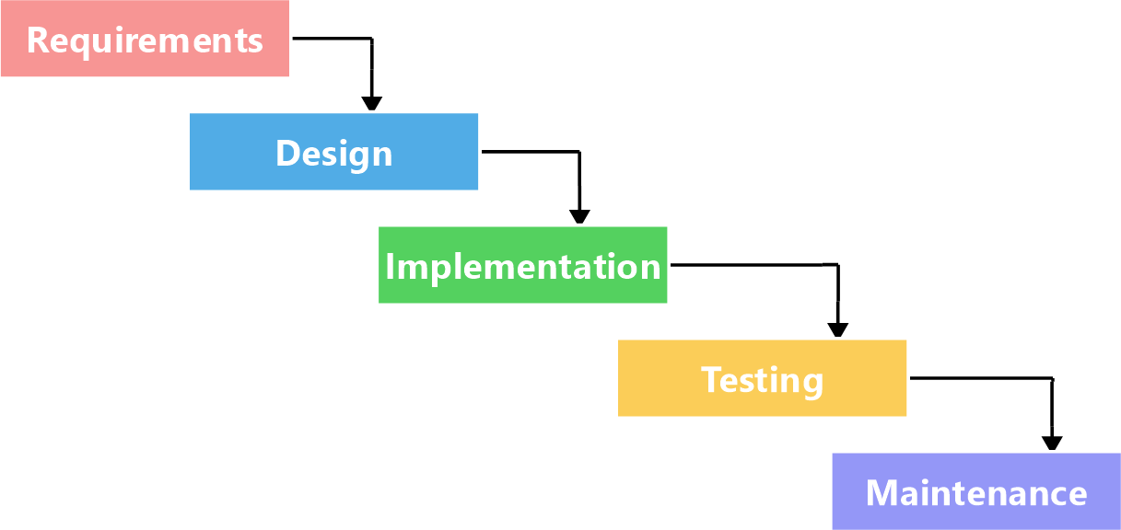

## Requirement Analysis and planning

A laptop on which the system will be constructed, money for the data-gathering procedure, and the acquisition of other items required for system development are some of the resources needed for this project.

For this project to be successful, having someone familiar with pharmaceutical operations concepts to serve as an advisor is important.

## Design Phase

The python programming language Flask framework will be used for the designing of the back-end of the system. We will use Visual Studio Code as the integrated development environment (IDE) to construct our backend and the code will run on any recent internet browser preferably Chrome, Microsoft Edge or Mozilla Firefox browser.

Using HTML, JS and CSS we will design the User Interface (UI)

## Implementation and Testing

The system will be set up and users together with the admin will receive user manuals and training on how to properly use the system after that the system will be installed on the serve and operations set to start

I will run a number of tests to make sure the code is running the way it is supposed to and that both the system and business objectives are in line to be achieved

## Release and Maintenance

The system will finally be released for use and I will be conducting regular maintenance such as system updates and back up.

## BUDGET AND RESOURCES

* + - A laptop with a minimum of 4 GB RAM and above, Windows 10
    - A suitable IDE should be used – Visual Studio Code
    - Wamp Server
    - A web browser, Google Chrome preferably
    - Stable and reliable internet The proposed budget is:

|  |  |
| --- | --- |
| **Resource** | **Estimated Cost** |
| Laptop(i7,8GB RAM 512GB SSD) | Ksh.57,000 |
| Reliable Internet | Ksh.5,000 |
| Miscellaneous Funds | Ksh.5,000 |
| Software | Ksh.10,000 |
| Human Labor | Ksh.50,000 |
| **TOTAL** | **Ksh.127,000** |

## PROJECT SCHEDULE

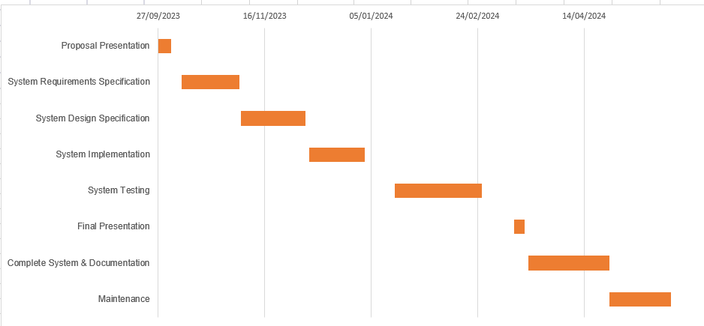

# REFERENCES

*Priya, R., Kumari, S., & Kumar, A. (2022). Research on Pharmacy management. ResearchGate.* [*https://www.researchgate.net/publication/360963051_Research_on_Pharmacy_management*](https://www.researchgate.net/publication/360963051_Research_on_Pharmacy_management)

*Sahay, V. (2019). Pharmacy Management System Project Documentation of Pharmacy Management System A Desktop Application. Tbump.* [*https://www.academia.edu/39277383/Pharmacy_Management_System_Project_Documentation_of_Pharmacy_Management_System_A_Desktop_Application*](https://www.academia.edu/39277383/Pharmacy_Management_System_Project_Documentation_of_Pharmacy_Management_System_A_Desktop_Application)

*https://www.coursehero.com/file/61647336/Pharmacy-Management-Systemdocx/*